County Councillor Update  Coker Division SCC  Cllr Mark Keating  September 2021 |  | 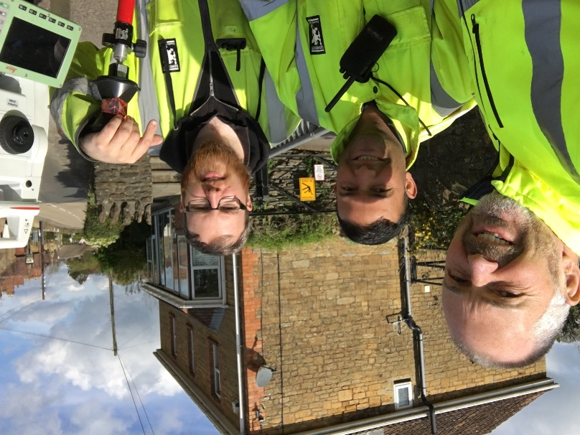
Representing you in - Barwick, Chiselborough, Closworth, East Chinnock, East Coker, Hardington Manderville, Hardington Marsh, Hardington Moor, Haselbury Plucknett, Middle Chinnock, Montacute, North Coker, North Perrott, Norton Sub Hamdon, ​Odcombe, Pendomer, Sutton Bingham, Stoford, West Chinnock, West Coker.
Useful Contacts Resources and Websites: Somerset Coronavirus Support Helpline: 0300 7906275
Cllr Mark Keating – Somerset County Council | E: MAKeating@Somerset.gov.uk | M: 07767 203968
South Somerset Area Highways Office | E: countyroads-southsom@somerset.gov.uk | T: 0300 123 2224
Report Pothole/Road Defect | E: roadsandtransportSD@somerset.gov.uk | T: 0300 123 2224
Report Dead Animal/Mud on Road | E: roadsandtransportSD@somerset.gov.uk | T: 0300 123 2224
Neil McWilliams – Highways Service Manager | E: countyroads-southsom@somerset.gov.uk | T: 0300 123 2224
Lee Norman/Derek Davies – Assist Highways Service Manager | E: countyroads-southsom@somerset.gov.uk | T: 0300 123 2224
Garry Warren/Rebecca Vaughan – Traffic Engineer. Traffic & Transport Development | E: countyroads-southsom@somerset.gov.uk | T: 0300 123 2224
Gully Emptying / Road Sweeper | E: chris.holley@southsomerset.gov.uk | T: 01935 462462
Nick Allen – SSDC Ranger Scheme | E: nick.allen@southsomerset.gov.uk | T: 01935 462462
Road Records & Highway Licensing | E: Roadrecords@Somerset.gov.uk | T: 0300 123 2224

Report Adult at Risk | adults@somerset.gov.uk |  |  | T: 0300 123 2224  T: Emergency: 999
Report Child at Risk | childrens@somerset.gov.uk |  |  | T: 0300 123 2224  T: Emergency: 999
Children’s Social Care Worker out of hours Emergency Duty Team |  |  |  | T: 0300 123 2327
Fostering and Adoption www.fosteradoptsomerset.org.uk | AandFRecruitmentEnquiryLine@somerset.gov.uk |  |  | T: 0800 587 9900
www.somersetwaste.gov.uk |  | ssdc@southsomerset.gov.uk | T: 01935 462462
https://www.travelsomerset.co.uk/ |  | Travel - Drive Bus Train Walk Cycle Weather
www.somerset.gov.uk |  | generalenquiries@somerset.gov.uk | T: 0300 123 2224
http://roadworks.org/ |  | Useful website for road works info
www.facebook.com/somersetcountycouncil |  | Somerset County Council Facebook page
https://roam.somerset.gov.uk/roam/map |  | Interactive Rights of Way Map / maintenance reporting
Coronavirus infection rates: As at 29th August the number of confirmed Covid cases in Somerset was 33,812 (up from 26,526 on 25th June) and the number of Covid-attributed deaths 811. The rate per 100,000 stands at 459.1 (206.9) for Somerset with Mendip at 358.2 (234.5), Sedgemoor at 673.0 (195.7), South Somerset 410.5 (214.4) and SW&T at 417.1 (187.0). The number of total deaths across the County is currently 11% below the 5-year average and the latest R-value for Somerset is between 0.9 and 1.2.

Infection rates in Somerset are now amongst the highest in England. It is therefore important even for those who have had both jabs to remember to observe Social Distancing and to Ventilate indoor areas at all times.

Somerset Coronavirus Support Helpline: A single phone number continues to be available for anyone in Somerset who needs Coronavirus-related support. 0300 790 6275, is open seven days a week from 8am to 6pm.

Vaccination programme roll-out: Somerset continues to have one of the highest vaccination rates in the country with the latest figures showing over 94.5% of the adult population having had one dose of vaccine and 84.6% having had both doses. Work continues to encourage further take up particularly amongst younger adults and a real focus on ensuring the second vaccine to this group.

Local Government Reorganisation: Following the Secretary of State for Housing, Communities and Local Government (MHCLG) decision to support the move to a single Unitary Council across Somerset work has now commenced to refine the transition and implementation programme. The four District Councils and Somerset County Council are working closely with MHCLG to implement the decision. A recent request from Government to look at a maximum of circa 85 Councillors on the new Council has also meant that a review of Divisional/Ward boundaries is now being undertaken. In addition, the impact of a May 2022 Unitary election on Town and Parish Councils who are not due to elect until 2023 is also under consideration with the views of these Councils being sought on the options available. It is expected that statutory orders will be laid before Parliament in the late Autumn and a vesting date of the new authority as April 2023.

Somerset Medal for Community Groups: Cllr Mark Keating, acting Chair of Somerset County Council recently presented Somerset Medal wards to individuals in Taunton. Mark said ‘’it was a privilege present these medals, to speak with and share experiences with so many selfless, community spirited individuals. They are the pride of Somerset, ensuring the vulnerable, the elderly and those in need received the support to get them through difficult and challenging times’’ Groups, teams and other volunteers will be presented with the Somerset Medal on Wednesday 15 September at Taunton Rugby Club after being recognised as some of Somerset’s many unsung coronavirus heroes. The Somerset Medal was launched by Somerset County Council to say a heartfelt thank-you to the best of the best. The first individual winners were announced on Somerset Day with a second round of nominations opened up to groups and teams.
£5,000 Rural Business Grants: Grants of up to £5,000 are now available to help businesses in rural parts of Somerset bounce back after the coronavirus pandemic. The grants (up to 80% of project costs) are available to assist service businesses in rural areas to help them move forward and become more sustainable. A business will need to provide 20% of their own match funding. The application process is open to Sole Traders providing rural services, Businesses providing rural services, Town and Parish Councils; Local Community led organisations operating on a not-for-profit basis and are legally constituted. The fund which is part of the wider £6m Somerset Recovery Fund will close at 5pm on 10 September 2021. Initial applications will be treated on a first come, first served basis but we will need time to check eligibility and respond. Details and application form can be found at www.somerset.gov.uk/business-and-economy/somerset-recovery-fund
Afghan refugees: Somerset County Council is committed to help a scheme to house Afghans who supported British military and to resettle interpreters and translators. People across Somerset have been stepping forward to help support Afghan refugees as the crisis being played out in the international spotlight deepens. The Council anticipates the Government will fund a number of places for refugees with strict rules on the types and locations of suitable accommodation. Anyone who would like to help in anyway should contact resettlement@somerset.gov.uk
Carbon Reduction: Over half of street lighting in Somerset is now eco-friendly and playing an important role helping the county work towards its 2030 carbon neutral target. Somerset County Council’s Highway Lighting Team has started to reduce its carbon footprint in the past five years thanks to the installation of LED lanterns in 56 per cent of street lighting stock. The LED replacements have seen a reduction in the carbon produced per year, down from 9,522 tonnes in 2015/16 to 3,278 tonnes in 2020/21: a reduction of 6,244 tonnes of Co2 and resulting in a 31.75% energy saving equal to £950,00 per year.
Care leavers guaranteed interview scheme: As part of Somerset County Council’s commitment to support care leavers, the council has agreed to extend its Care Leaver Guaranteed Interview Scheme to anybody who was in care as a child, wherever that was, and whatever their age now. This means people who have been in the care of a Local Authority for a significant period before the age of 16 and apply for a job with Somerset County Council will be guaranteed a job interview – provided they meet the essential job criteria.

Recent Press releases:

Pop-up Covid vaccination clinics
Somerset campaign encourages residents and tourists to ‘think twice’ this summer
Notice of vacancy (following the sad death of County Councillor Alan Wedderkopp)
Covid-19 testing remains key as self-isolation rules change
£500,000 to boost re-start and recovery
Joint crackdown aims to put brakes on speeding motorists

